About ACG Join Donate Store Find a GI My ACG/Log In



Membership Education Clinical Guidelines Publications Trainees Patients & Families

**Public Policy**



**This Week in Washington D.C.**

What’s happening on the hill?

Have an issue in your state? ACG can help.



Contact your ACG Governor

**Something we want to highlight.**

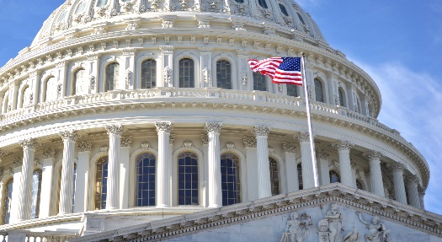

ACG Legislative   
Action Center

**Take action now! ☑**

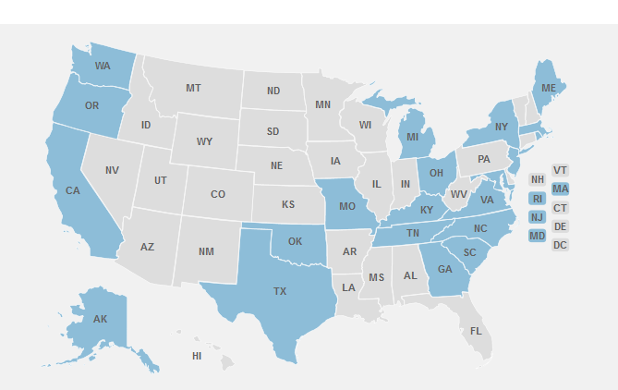

Get involved at the state & local level.  
Be an advocate for ACG and your state GI society.

**Static Fly-In Photo Collage (updated each year)**

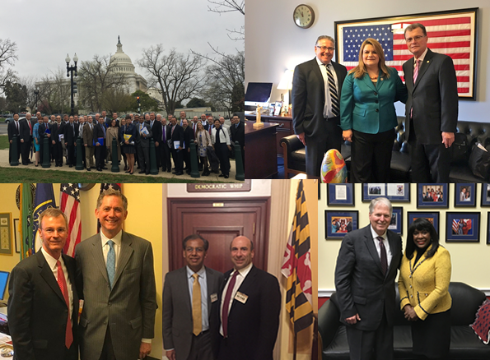 SafeFty Alerts, ACG FDA Committee News, & more

Contact Us:

Name: 

Email:

Message: 